

Twin Lakes Playhouse Program Ad Sales Form

The Twin Lakes Playhouse invites you to take advantage of our program ads! Our 2024 season consists of five plays with something to appeal to everyone. The ad you purchase today will appear in every program for each performance of all 5 shows in 2024. Please consider this incredible advertising opportunity that will help support the theater arts in the Twin Lakes area.

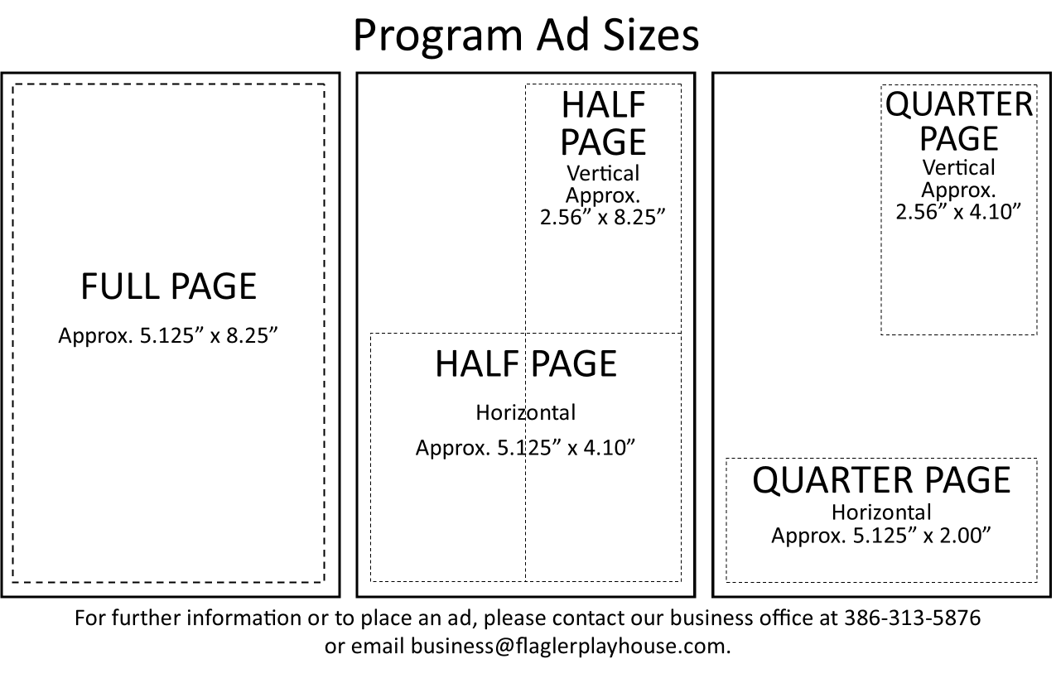

**Step 1: Choose ad size**

1/8th page $75 _____

1/4 page $125 ____

1/2 page $200 ____

Full page $300 _____

Inside Back Cover $400 _____

Inside Front Cover $600 SOLD

**Step 2: Submit your ad using one of the following options**

* Email your ad (jpg or pdf) to [twinlakesplayhouse@gmail.com](mailto:twinlakesplayhouse@gmail.com) (preferred method)
* Attach a copy of your ad to this form. Note- this works best if the copy you provide is black and white and at least the size of the ad you are ordering. Larger is better than smaller! Mail to Twin Lakes Playhouse, PO Box 482, Mountain Home, AR, 72654

**Step 3: Provide payment**

___________ Payment enclosed with ad

___________ Call the Playhouse at 870-424-0444 and leave a message. A volunteer will return  
 your call to discuss payment options.

**Step 4: Business Information**

Business Name: _________________________________

Mailing Address: ________________________________________________ Zip: ____________________

Contact Name: _____________________________________________

Email: ___________________________________________ Phone: __________________

Deadline for ads is January 15th, 2024 to be included in all 5 shows.